Guidelines for managing glyphosate resistance risk in amenity weed control (UK)
Issued by the UK Weed Resistance Action Group (WRAG) in partnership with the Amenity Forum – 8 October 2026.

Key messages
- Glyphosate resistance is now present in UK agriculture.
- The risk of glyphosate resistance in amenity situations is high.
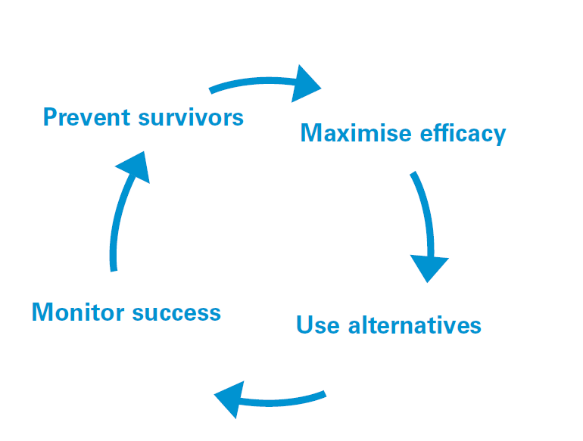
- Use glyphosate at the correct dose, to small actively growing weeds and under optimum conditions.
- Ensure glyphosate use is within an IPM, integrated vegetation management, approach.
- Monitor and act on survivors.
- Consider resistance testing of survivors if needed.

Monitor success:
- Consult your adviser or supplier.
- Remove survivors to prevent spread.
- Test seed samples of survivors.

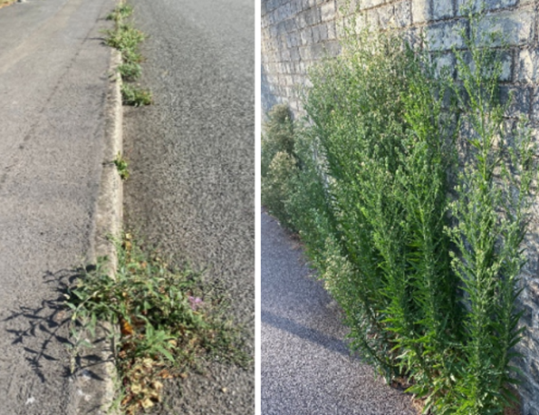
Prevent survivors:
- Avoid repeat application to surviving plants (this presents the highest risk).

Maximise efficacy:
- Use the right dose rate for the target weed on actively growing plants.
- Reduced rates increase risk of reduced efficacy.

Use alternatives:
- Use other non-chemical control when practical (IPM).
- Use other herbicides in sequence (or mixture only if recommended).

Background
Glyphosate is widely used in amenity situations. Repeated use increases resistance risk, especially where weeds survive treatment. In 2025, the UK confirmed its first glyphosate-resistant populations in Italian ryegrass in an arable crop. All the cases identified as resistant or high risk of being so, are from high-risk management situations (no cultivation and/or very little soil disturbance, larger weeds allowed to grow without earlier control when small). It is likely that all cases have evolved from independent selections. There is no geographic pattern to their incidence.

Herbicide resistance is when weeds survive a dose that would normally control them. Repeated use of the same herbicide allows resistant plants to dominate. Amenity weed control presents a particular risk for the development of herbicide resistance due to the reduced herbicide options now available.

Although much of the relevant information on resistance management has come from work in arable crops it is still very relevant to other situations, including amenity and horticulture where the inherent risks are much greater.

The WRAG Guidelines for minimising the risk of glyphosate in the UK, first published in 2015 and informed by AHDB (levy) & industry research, remain highly relevant and the emerging resistance cases all highlight why they were produced and the need to use them. They key management include: Preventing survivors, Maximise efficacy, Use alternatives, and Monitor success. This leaflet provides amenity situation specific information on the resistance threat and indicates how to spot and manage developing risks.

What is resistance?
- Herbicide resistance is the inherited ability of a weed to survive a dose of herbicide which would normally give effective control.
- Any weed population may contain a very small proportion of plants resistant to a specific herbicide. Repeated use of that herbicide removes susceptible plants, allowing the resistant plants to survive and multiply. Eventually the resistant plants dominate the population and the herbicide fails to give any useful level of control.
- Resistance is usually a progressive process, with susceptible weed populations gradually becoming more resistant over time as a consequence of repeated application of the same herbicide mode of action.
- Annual weeds are more likely to develop resistance than perennial weeds.
- The limited number of herbicides available for amenity weed control increases the risk of resistance due to greater reliance on a smaller number of active substances (e.g. glyphosate).

Canadian fleabane (Erigeron canadensis, Figure 1), is one of the most common weeds to have developed resistance to glyphosate worldwide. Seeds of Canadian fleabane are easily spread by wind, which is one reason why glyphosate-resistant forms have become a major problem in several countries.
Figure 1. Canadian fleabane during flowering
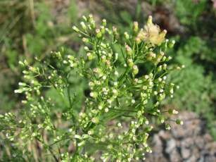

Resistance to glyphosate, and other herbicides, can potentially develop in any weed

Glyphosate resistance:
- Glyphosate is the most commonly used herbicide in amenity weed control situations.
- Preventing resistance to glyphosate is a priority because alternative herbicides are often more expensive and less effective.
- Glyphosate resistance was first reported in 1996 and has now been found in 62 different weed species globally.
- In Europe, glyphosate resistant weeds have been found in several countries, including France, Greece, Italy, Portugal and Spain.
- The weed species includes Lolium species (Persian/Italian/rigid and perennial ryegrass), Bromus (Bromes), Amaranthus (Amaranth), Echinochloa (Barnyard grasses) and Erigeron (fleabane) mainly in orchards and vines. There are also cases in amenity (rail and road).
- In 2025, the first UK cases were reported in a small number of locations in arable crops. Monitoring so far has been in arable crops and we have identified cases of resistance in Italian ryegrass. Bromes are also a species of concern.
  - All the cases identified as resistant, or high risk of being so, are from high-risk management situations (no cultivation and/or very little soil disturbance, larger weeds allowed to grow without earlier control when small).
  - It is likely that all cases have evolved locally and independently. There is no geographic pattern to their incidence.

Resistance management

Monitor success: procedure for spray operators and managers in the event of herbicide control failure
- Good record keeping and assessment after spraying are essential in the early detection of herbicide resistance.
- Monitor and assess herbicide efficacy after spraying in order to detect any loss of control.
- If herbicide resistance is suspected, act quickly to prevent it spreading. Use a strategy involving alternative herbicides and non-chemical methods and continue to monitor.
If spraying fails to control weeds and you suspect resistance to any herbicide, first check that the following apply to your particular situation before taking further action:
- The herbicide is recommended for control of that particular weed species.
- The correct herbicide dose and application method was used.
- The weather and other conditions were favourable for control at the time of spraying.
- That surviving weeds were not simply spray misses 'shaded' from the spray, or plants that emerged after spraying.

Testing helps confirm resistance early and allows corrective management. The Maximising the benefits of herbicide resistance testing leaflet contains more information.
- Ensure you collect representative samples and seek relevant advice.
- Testing seed (or plant) samples is available and essential to confirm resistance through your adviser or contact weeds@adas.co.uk.

Prevent survivors: the resistance danger signs – what to look for
- Isolated plants surviving treatment when most plants of the same species are killed.
- Patches of weeds surviving treatment for no obvious reason.
- A gradual decline in control over several years.
- Repeated annual use of the same herbicide mode of action.

Do not retreat surviving weeds with glyphosate! This presents the highest risk of selecting for resistant plants. Consider alternative modes of action, mechanical or hand weeding.

Maximise efficacy: the right dose, at the right time with the right equipment
- Carefully plan your weed control programme but remember that the timetable needs to be flexible to cope with conditions.
- Always use recommended dose rates – reduced rates are proven to increase resistance risk.
- Spray small, actively growing weeds which are easier to control.
- Apply in suitable weather conditions. Do not apply in drought or during rain or when weed leaves are excessively wet or rain is expected. Moderate temperatures favour efficacy. Low temperature will give results but activity will be slow. High temperatures causing scorch or stress will lead to poor uptake and poor performance.
- Ensure good spray coverage. Correct nozzles, spray pressure and water volumes will optimise coverage and maximise control. Litter can hide weeds and dust can limit uptake.
- Use the correct dose for the situation – in plant free areas 1800g/ha (5L of 360g/l glyphosate) will control seedlings as well as overwintered perennials.
- Refer to labels and technical information supplied by glyphosate manufacturers.

Use alternatives: practical measures to manage herbicide resistance risk in amenity situations
- Avoid over-reliance on glyphosate. Where possible use mixtures of herbicides however only use if approved for use on the surface being targeted.
- Consider non-chemical control measures (for example hand weeding, cutting, flaming, steam treatments) as a supplement or alternative to herbicide treatment.
- Plan to apply the herbicide following brushing or sweeping or, ideally in rotation with brushing or sweeping regimes. This can help remove small weeds and remove debris build up so larger weeds are less able to survive. This basic hygiene method is provides good longer term weed control, forms part of an Integrated Weed Management (IWM) strategy and prevents the over reliance on chemical control.
- Electrical weeding methods are now more widely available. This technology provides effective weed control and can be used in windy weather conditions, so more flexible than spraying. It can be used in conjunction with chemical control as an IWM approach for maximum control. Electrical weeding is very targeted and can be used in areas where weeds need to be selectively removed from surrounding vegetation.
- Foam weeding is an alternative technique that is effective for smaller weed species (annuals). This is often favoured for parks and garden pathways rather than pavements and highways, due its high cost and the need for a large volume of water.
- Mechanical control techniques can provide very effective control of small annual weeds however control of perennials may be limited if roots fail to be removed. Such physical methods can help reduce reliance on chemical control and can form a useful part of IWM strategies.

Prevention of resistance is much easier than cure. Early detection of resistance is vital. Resistance has the potential to increase the costs and complexity of amenity weed control situations. If resistance is ignored, weeds can rapidly become unmanageable using herbicides. Recognition of resistance must become a priority in all amenity weed control areas.

If you suspect resistance, in the first instance contact the company selling the product or a suitably qualified technical expert or agronomist.

Further information and contacts

Visit the WRAG homepage
Visit the Amenity Forum website
Join the LinkedIn group for up-to-date information and news

ADAS/WRAG: James Clarke, Chair WRAG, and Lynn Tatnell, Principal Weed Scientist, ADAS: weeds@adas.co.uk
Amenity Forum: admin@amenityforum.co.uk

Use the EPPO database of resistance cases
Use International herbicide-resistant weed database
Read Bayer’s glyphosate FAQs
See HSE updates on glyphosate active substance renewal

This leaflet was updated by James Clarke, Lynn Tatnell, John Cussans (ADAS) and Barrie Hunt based on the original document from 2009 on behalf of the UK Weed Resistance Action Group (WRAG). We acknowledge the original funding from HSE/CRD and input from Rothamsted Research.

